Standard: | Items:
5.MD.01 -  Convert among different-sized standard measurement units within a given measurement system (e.g., convert 5 cm to 0.05 m), and use these conversions in solving multi-step, real world problems. | 3.0:  - In the long jump, Debbie can jump 4 feet 4 inches and Margaret can jump 1 yard, 1 foot, 1 inch. Who jumped the farthest? How many inches farther did that person jump?  - Mrs. Hinojosa had 8 strips of ribbon that each measure 15 centimeters (cm). How much ribbon does she have altogether in millimeters (mm)?  - One can of soda has a capacity of 355 mL. How many liters of soda does 8 cans contain?
2.0
- A detergent bottle holds 700 milliliters. Find the capacity in liters. (answer: 0.7L)
- A bag of potatoes at the grocery store weighs 5 pounds. How many ounces does the bag of potatoes weigh?
- 180 inches = _____ yards (answer: 5 yds)
- 3 meters = _______ centimeters (answer: 300 cm)
5.G.01 -  Use a pair of perpendicular number lines, called axes, to define a coordinate system, with the intersection of the lines (the origin) arranged to coincide with the 0 on each line and a given point in the plane located by using an ordered pair of numbers, called its coordinates. (0,0)  Understand that the first number indicates how far to travel from the origin in the direction of one axis, and the second number indicates how far to travel in the direction of the second axis, with the convention that the names of the two axes and the coordinates correspond (e.g., x-axis and x-coordinate, y-axis and y-coordinate). | 3.0  - On the coordinate plane below:  - label the x and y axes  - label the origin  - write the coordinates for  Point D _________ Point A _______ Point K ________ Point F _________  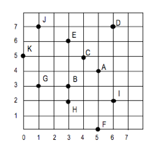  - Review the coordinate plane below and perform the tasks below.  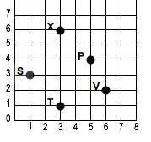  - Name the ordered pair that is at point P. (______, ______)  - Name the point that represents the ordered pair for (1, 3). ______  - Plot any point on the grid above and label it Z. What is the ordered pair for this point? (______, ______)  - Label the x and the y axis on the coordinate grid above.  - Label the origin on the coordinate grid above.
2.0
- Label the x axis and y axis
- Circle the origin on the coordinate plane

- Which coordinate grid shows the points (1,2), (2,4), and (3,1) graphed correctly?
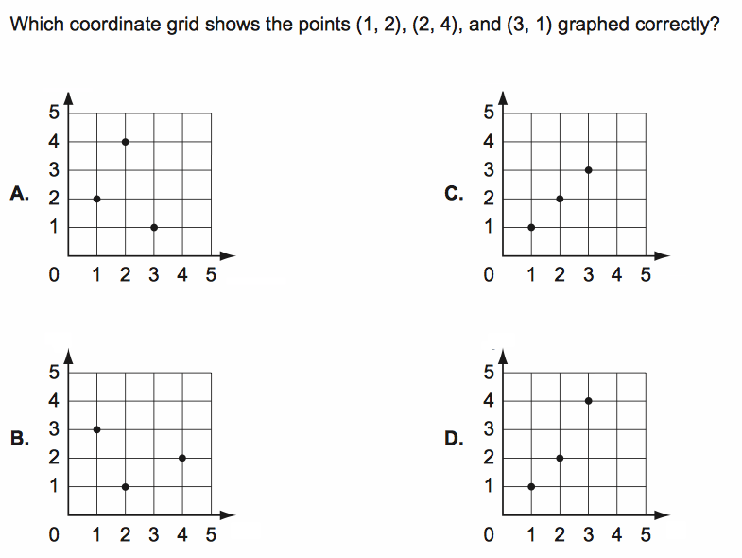

NBT 1  Recognize a digit is 10X the digit to the right and 1/10 the digit to the lef | 3.0  1a. Mrs. Lopez has driven 19,345 miles since she got her new car. Mr. Lopez has driven 12,976 miles since he got his new car. How many times greater is the 9 in 19,345 than the 9 in 12,976?  - 10 times greater*  - 100 times greater  - 1,000 times greater  - 10,000 times greater  1b. In which number does the 6 have a value that is one-tenth the value of the 6 in 34,761?  - 16,305  - 28,695  - 51,364  - 78,426*
2.0
- Bob has ran 561 miles this month to train for a race. Stephanie ran 624 miles. How many times greater is the 6 in 624 than 561?
  - 10 times greater*
  - 100 times greater
  - 1,000 times greater
  - 10,000 times greater

- In which number does the 3 have a value that is one-tenth the value of the 1,321?
  - 7,432*
  - 3,652
  - 358
  - 673

- Which statement is true about the value of the underlined digit in the number forty-four? 44
  - It is 10 times less than the value of the 4 in the ones place.
  - It is 100 times less than the value of the 4 in the ones place.
  - It is 10 times more than the value of the 4 in the ones place.*
  - It is 100 times more than the value of the 4 in the ones place.

NBT 7  Add and subtract decimals to the hundredths (pending other operations on purpose) | 3.0  17. Solve the following problems showing your work clearly in three ways.  A. 0.25 + 0.82 =  Solve the problem above using grids or another model or drawing.  Solve the problem above using another strategy. Clearly show your work.  Explain how your answer makes sense.  B. 0.73 - 0.46 =  Solve the problem above using grids or another model or drawing.  Solve the problem above using another strategy. Clearly show your work.  Explain how your answer makes sense.
2.0
14) Solve 0.37 + 0.02 =
15) Solve 0.87 - 0.45 =
16) Solve 0.5 + 0.4 =

5.OA.3 | 2.0  Given the pattern M = 2+P, complete the table below.  P 1 2 3 6  M 3 4 5  Identify the relationship between the two terms in the function table below.  A 2 3 4 5 6  B 4 6 8 10 12
3.0

Fred has to make toast for his family. It takes one minute for him to make two pieces of toast. Let x represent minutes and y represent the amount of toast Fred makes. Complete the table below and graph the ordered pairs.

X | 1
Y | 2

